Reducing Tees
Always: Run x Run x Branch
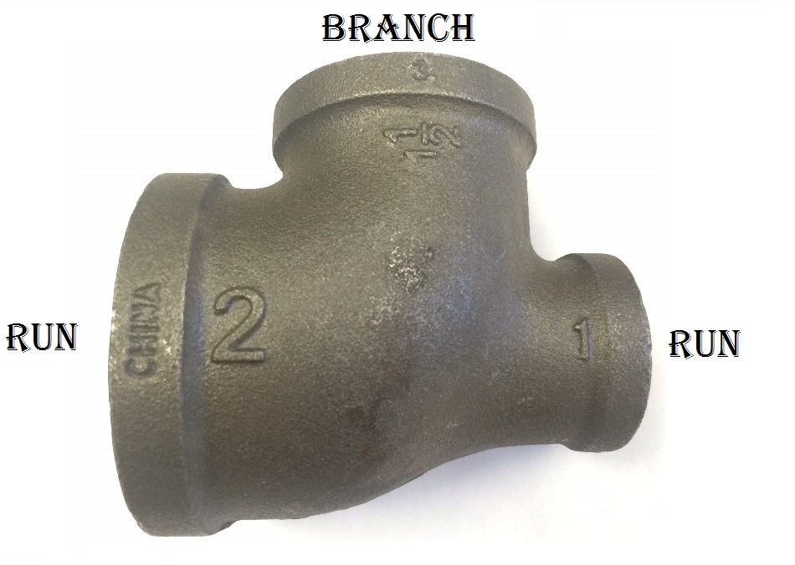
Example: The above should read: 2” x 1” x 1-1/2”

